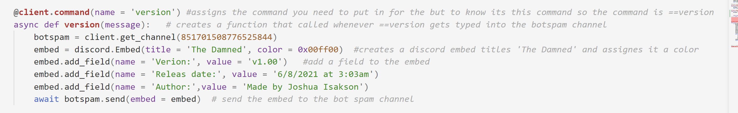

This shows comments, code organization, callable functions

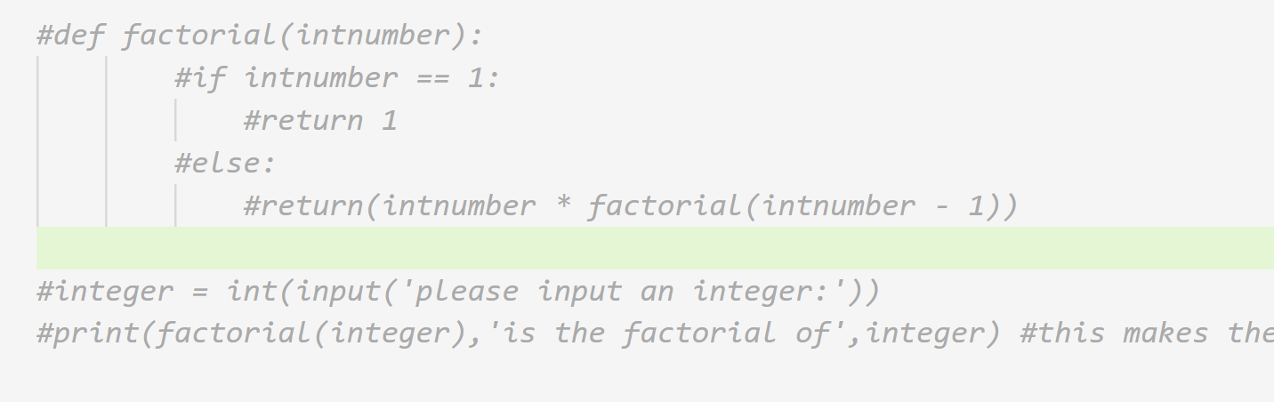

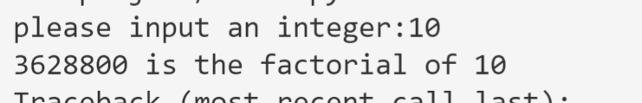

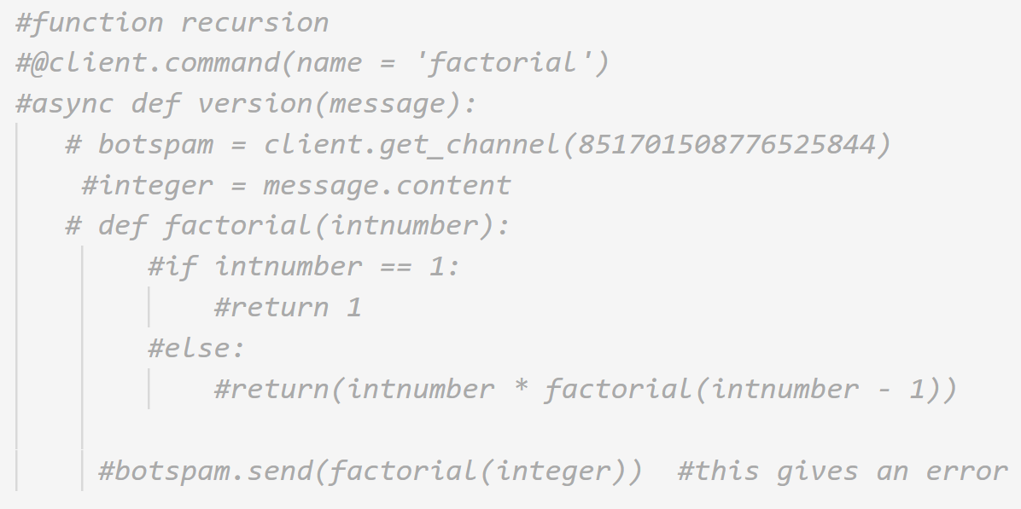

Tried making it integrated and it broke

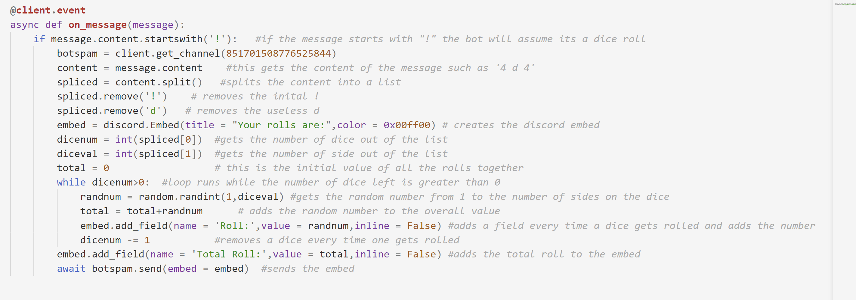

This displays strings, loops and some basic math

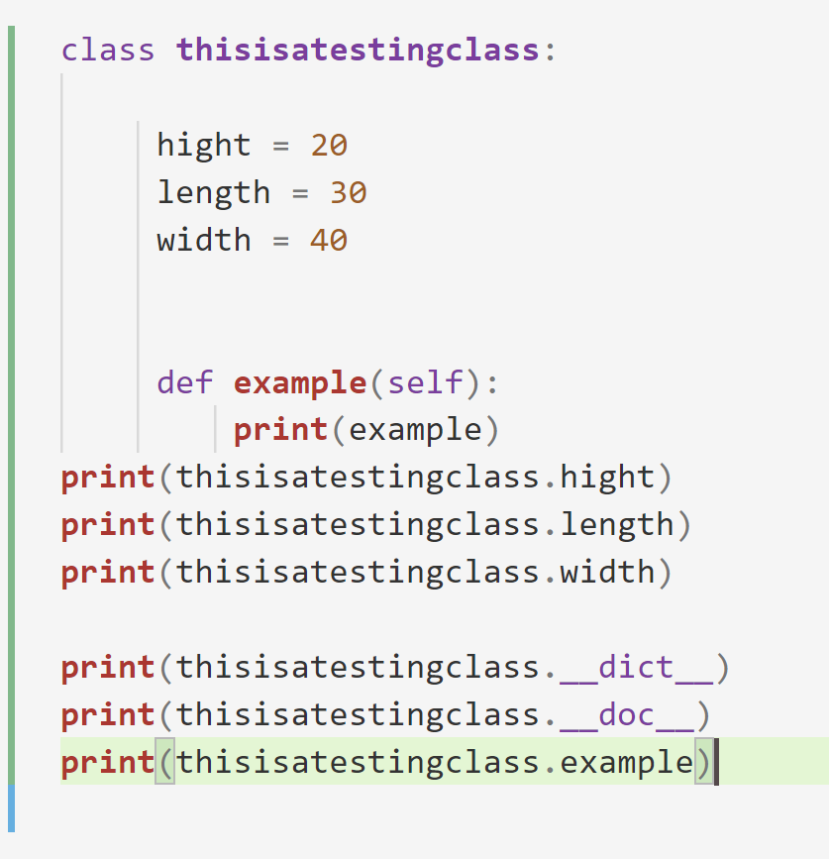

This is a class in the program that hold the dimension of a box or something

And now it broke

For no reason so I cant take good pictures of it working

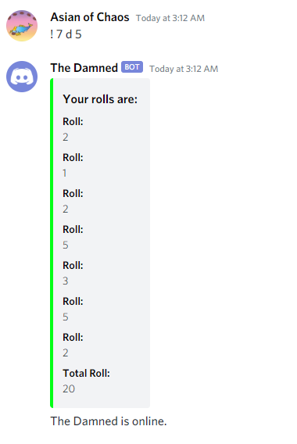

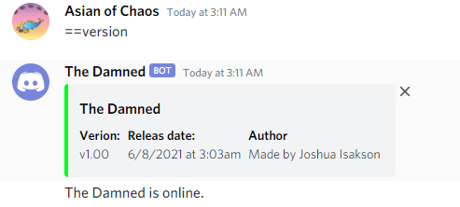

These all display the user interface parts of the program

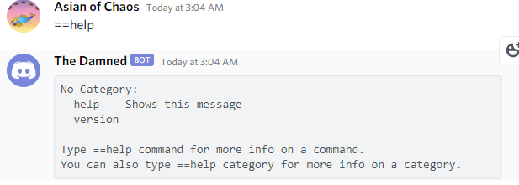

This one speaks to me